**PRESS RELEASE** 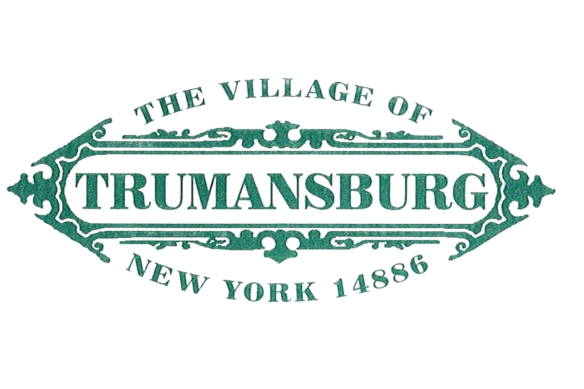

**56 E. Main Street Trumansburg, NY 14886**

For Immediate Release Contact: Trustee Ben Darfler

darfler@trumansburg-ny.gov

**Village of Trumansburg Draft Zoning Update Proposal Available**

After a year of effort, the Village of Trumansburg’s Comprehensive Plan and Zoning Revision (CPZR) Committee has released a draft proposal for updates to the Village's residential zoning regulation. All Trumansburg residents are encouraged to provide feedback on the draft proposal to guide the CPZR Committee as it continues to revise the draft proposal before recommending it to the Village Board of Trustees for potential adoption at the end of the year.

The draft proposal along with a frequently asked questions document can be found online at <https://tinyurl.com/TburgZoning>. Paper copies are available at the Village Office (56 East Main Street).

A public presentation followed by questions and feedback will be held at the Village Meeting Hall (56 East Main St) on September 7th at 7 pm. Remote attendance is available via Zoom at <https://tinyurl.com/TburgZoningMeeting>. Residents can also send feedback by email to [PublicComment@trumansburg-ny.gov](mailto:PublicComment@trumansburg-ny.gov).

The process leading up to this draft proposal began with the revision of the Village’s Comprehensive Plan, starting in 2018 and culminating in the adoption of a new plan at the end of 2021. The proposed zoning revision is built upon the vision laid out in the new Comprehensive Plan, which includes a desire for more affordable housing and rentals as well as a desire for infill residential development in vacant and underutilized properties.

Rather than taking years to complete the revision of the entire zoning law in one go, the CPZR Committee has broken the zoning revision process into three smaller projects, in hopes of getting increased input from the community.

This staged approach also begins to build a practice of revisiting the zoning on a more regular schedule than every few decades, as the Village has in the past. Revising zoning on a more regular basis allows for quicker course correction and faster response to changes in the community. It also provides increased opportunities for community input along the way.

The first draft proposal focuses primarily on the residential sections of the Village’s zoning law. This focus was chosen since the primary land use in the village is residential, and since residential zoning has received increased scrutiny over the past few years due to both an increase in residential development and a growing need for affordable housing.

Additional information regarding the Village Board’s review and potential adoption of the draft proposal will be posted on the Village Website at <https://trumansburg-ny.gov/> as it becomes available.